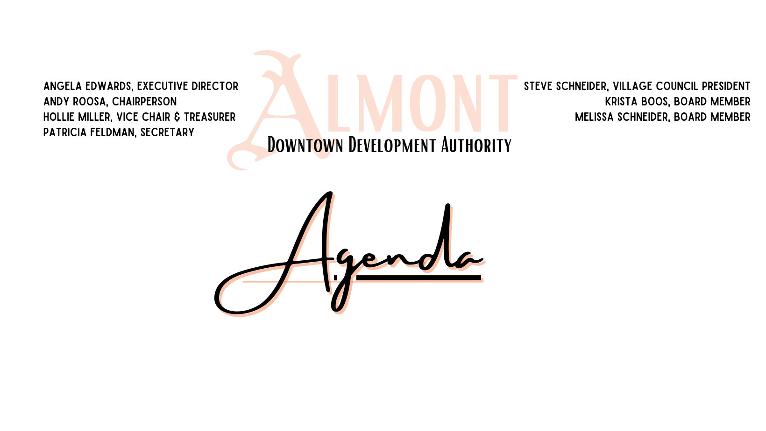

May 9, 2023 6:30 PM

Work session

**Call to Order**

**Attendance:** Roll Call

**Additions/Deletions to Agenda:**

**Communications:**

**Public Comments (Agenda Items):**

**New Business:**

**Finance:**

Approval of Bills Payable

**Open Discussion:**

Board Workshop- Roles of a Board Member Webinar & Open discussion

**Public Comments (Non Agenda items):**

**Board Questions and Comments:**

**Future Agenda Items:**

**Adjourn**